**Requirement Gathering and Analysis Phase**

**Solution Architecture**

|  |  |
| --- | --- |
| Date | 7 July 2024 |
| Team ID | SWTID1720171927 |
| Project Name | Project- SB Foods-Food Order App |
| Maximum Marks | 2 |

**Solution Architecture:**

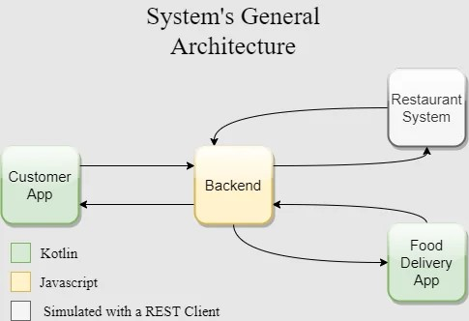

Customer:

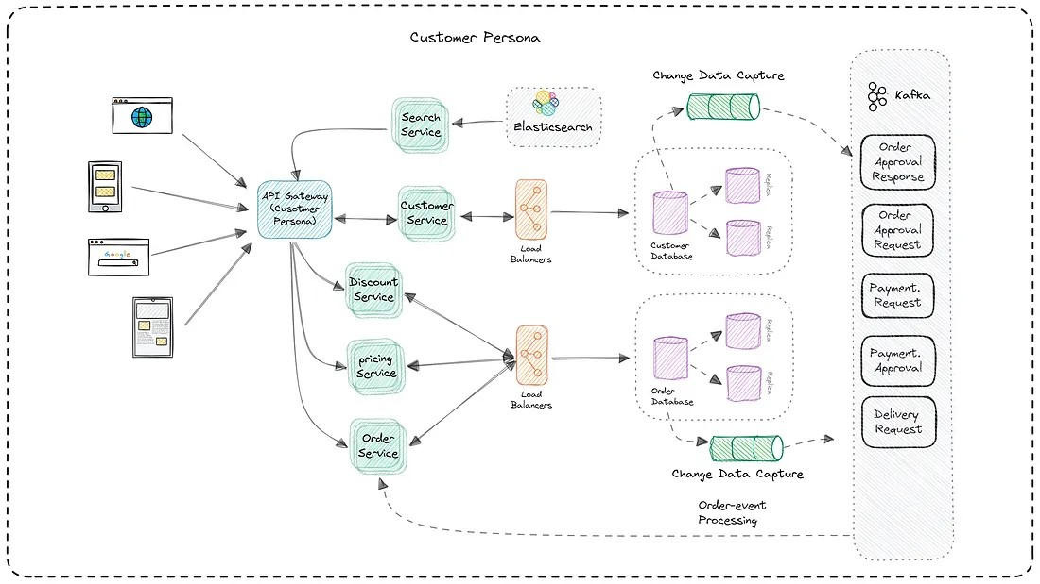

**Account Kit:** To let the user Sign in with his Id

**Auth Service:** To let the user Sign in with his Facebook, Google or email account

**Identity Kit:** To quickly retrieve the user's address

**Map Kit:** To display the roadsman location

**Push kit:** If the app is closed, the user will be notified about his order status

Restaurant:

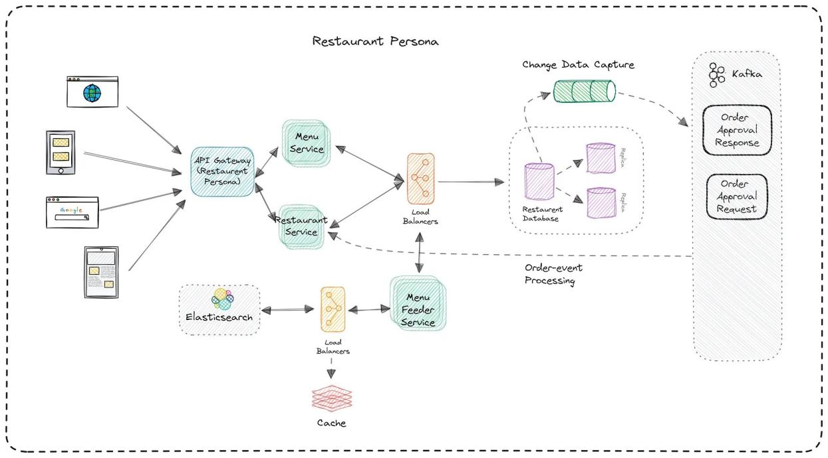

System Back end:

**Push kit:** The Push API will be invoked from here to notify changes in the order status.

**Site Kit:** The forward geo coding API will be used to get spatial coordinates from the customer's address.

**Cloud DB:** A database in the cloud to store all the orders and user's information

**Cloud Functions:** We can use cloud functions to handle all the business logic of our backend side.

Payment System:

